Dynamic Models in Biology

Lab 4

Jonathan Levine

Fall 2023

**Oscillations (Given Code)**

You can clearly see in the traces below that the 3 state variables settle into a fixed cycle/oscillation after some amount of time:



  
  
  
  
  
  
  
  
  
  
  
  
  
  
Zooming into one of the time traces, we can get an estimate for the period of oscillation, which seems to be about 7 hours:

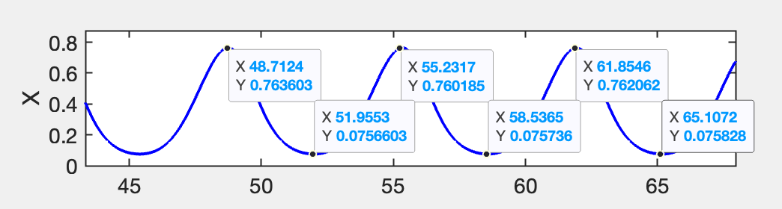This is maybe slightly faster, but not too different from the period in Figure 4, which was about 8/8.5 hours.

**Effects of initial conditions**

Just trying a few initial conditions at first, the period and amplitude do not depend on the initial conditions, although the phase does change.





To be sure, I tested 64 different combinations of initial conditions (each condition with 4 options, 4^3=64), and each time the fixed cycle occurred at the same values, with the same period. The only thing that changed is relative phases, and there are no other stable attractors other than this fixed cycle. This figure is a bit crowded, but I wanted to really make sure that no matter what starting points I chose, the amplitude did not change.

  
  
  
  
  
  
  
  
  
  
  
  
  
  
  
  
  
  
  
  
  
  
 **Stop the oscillation**

First, I tested the parameter n, the exponent in the sigmoidal term describing the activation of P53 by S. If we were to decrease n, (like the HPG endocrine example) I would expect that the oscillation might stop since we are dampening the steep non-linearity, which is usually necessary to induce a fixed cycle. In this case, I reduced n to 2, and the oscillations stop, and instead the system reaches a fixed point:

Next, I tried to change the p53 differential on the other side, by increasing the coefficient of degradation, $α_{xy}$. This did not have the desired effect, but rather increased the oscillation’s amplitude. I realized that this term is critical for the “down” phase of the oscillation, and thus it would make more sense to *decrease $α_{xy}$.* This stopped the oscillations:



Finally, I wanted to try to stop the oscillations by decreasing the time delay, which can often disrupt oscillations in DDEs:



**Alternative Model**

****I implemented the alternative model and simulated two different starting conditions. Here too we can see the period is consistent (although there is a phase change), and the oscillation tends to be a more “relaxed” one. However, the amplitude in this model is very sensitive to the initial conditions, indicating multiple stable attractors.

**Comparing Phase Shifts**

To compare phase shifts between p53(X) and mdm2(Y) in the two models, I wanted to plot those time trajectories over each other for each model:



T  
The phase shift between X and Y in the original model (with S) is only about 2 hours, whereas the one on the right (without S) is over 5 hours. The model with S on the left, clearly matches the data better where the phase shift between X and Y was small (<2.5 hours).

**Increased DNA damage**Increasing beta by a factor of 2 in the alternative model without S (right) only seems to affect the amplitude, but not the period or phase of the oscillations. This is different than the original model (left), where doubling beta changes the period/frequency of the oscillations. Given that the researchers found the frequency of p53 oscillations would increase with increased DNA damage, the more complex model with S (left) would seem to be more accurate to the data.

